Städt. Gesamtschule Iserlohn/ Iserlohn Comprehensive School has successfully applied for Erasmus+ 2018/19 as coordinating school in

Jazz meets Anatolia - Magic and fusion of sounds at meeting of Orient and Occident an international student exchange project in the field of music and arts for the personal and cultural development of young people

Project partners are:
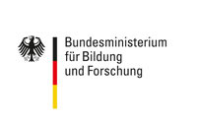
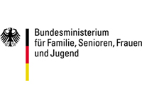
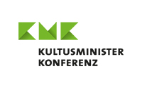
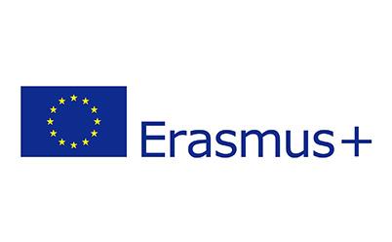
Özel AKA Koleji Istanbul-Bahçelievler/ Private AKA School Istanbul Bahçelievler [Turkey]
Özel AKA Koleji Tekirdağ/ Private AKA School Tekirdağ [Turkey]
Städt. Gesamtschule Iserlohn/ Iserlohn Comprehensive School [Germany]

